SVKM’S NMIMS
Mukesh Patel School of Technology Management & Engineering
Department of Computer Engineering
Java Lab
Subject- Object Oriented Programming through JAVA

EXPERIMENT NO. 5

Aim: To study types of inheritance, method overriding, abstraction-abstract class, abstract
method.

Name: Saumya Sura | Roll no.: C147
Division: D1 | Date of Experiment: 27/2/2026

1. A class “student” defines student with data members name, roll number and date of birth
and methods as Inputdata(). Inputdata() accepts the input for instance variable. Derived the
class “marks” from class “student” defines marks of various subjects, total percentage and
grade of the student and methods as readdata() reads the marks out of 100, compute()
calculates the percentage and assigns the grades accordingly, show() displays the name, roll
number and date of birth, marks in various subjects, total, percentage and grade.
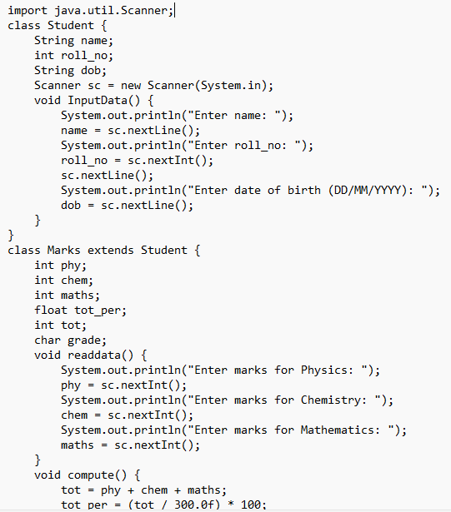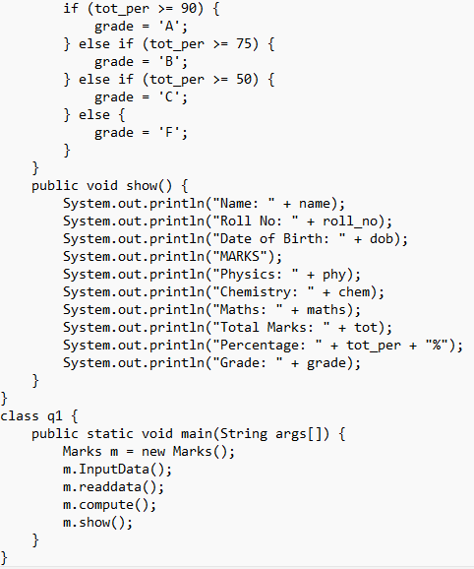

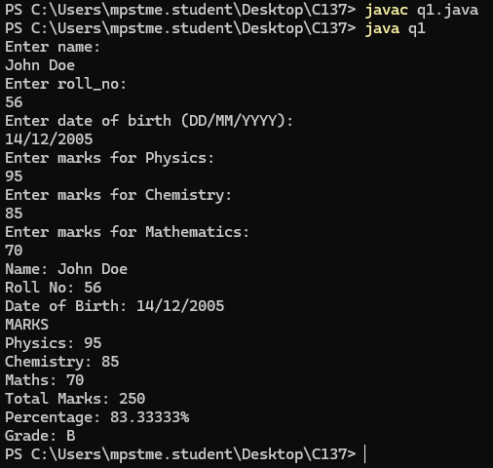
2. Create a class “Person” with fields “name” and “age” and a method “display()” that prints
the name and age of the person.
Create a subclass “Employee” that extends “Person” and adds a field “salary” and a method
“display_Emp()” that prints the name, age, and salary of the employee.
Create a subclass “Manager” that extends “Employee” and adds a field “department” and a
method “display_Manager()” that prints the name, age, salary, and department of the
manager.
Create an object of the “Manager” class and call the “display () , display_Emp() and
display_Manager ()” method.
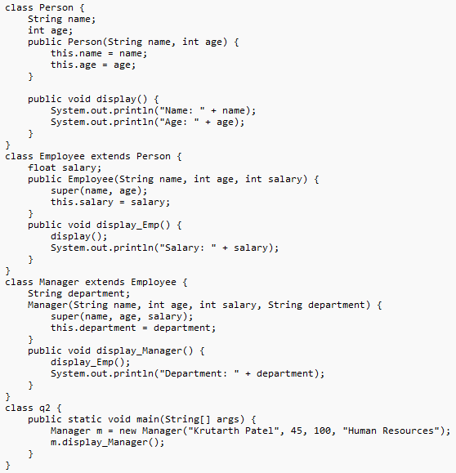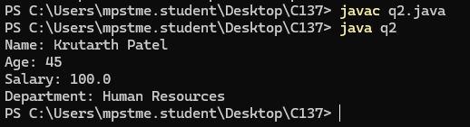
3. Create a class “Vehicle” with a method “drive ()” that displays a message “Driving a
vehicle”. Create two subclasses “Car” and “Bike” that extend “Vehicle” and implement the
“drive_car ()” and “drive_bike ()” method to display “Driving a car” and “Driving a bike”
respectively.
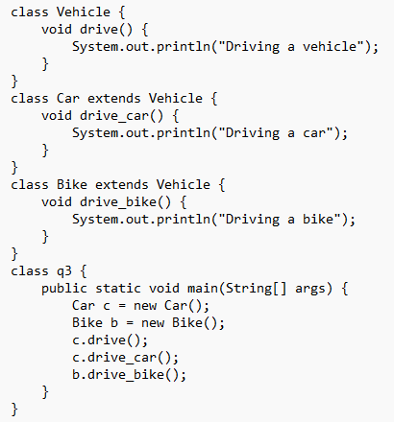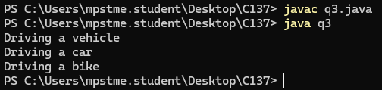
4. Create a class “Person” with a method “speak ()” that displays a message “The person is
speaking”. Create two subclasses “Student” and “Teacher” that extend “Person” and
perform the “speak ()” method to display “The student is asking a question” and “The
teacher is giving a lecture” respectively.
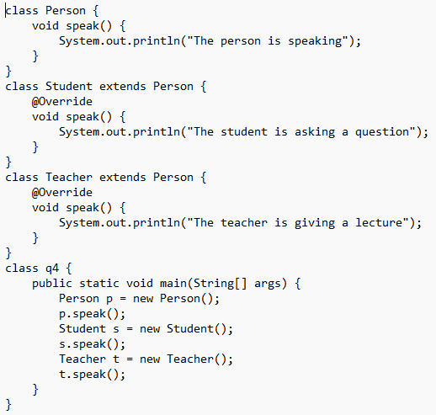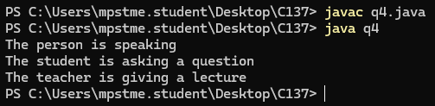

5. The program now uses a "Flight" base class and its subclasses "PassengerFlight" and
"CargoFlight." Each subclass overrides the “fly()” method to provide specific behavior.
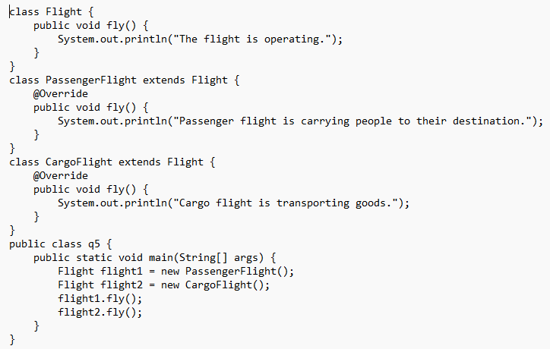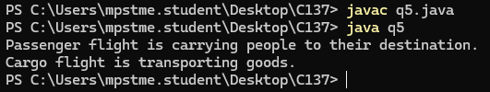
6. Write a Java program to create an abstract class Shape3D with abstract methods
calculateVolume() and calculateSurfaceArea(). Create subclasses Sphere and Cube that
extend the Shape3D class and implement the respective methods to calculate the volume
and surface area of each shape.
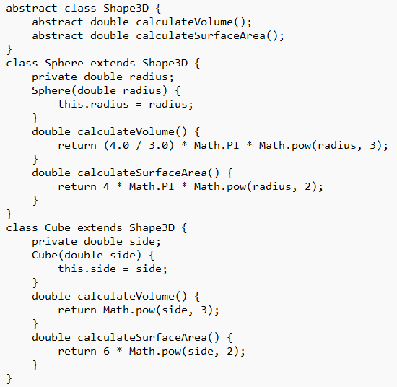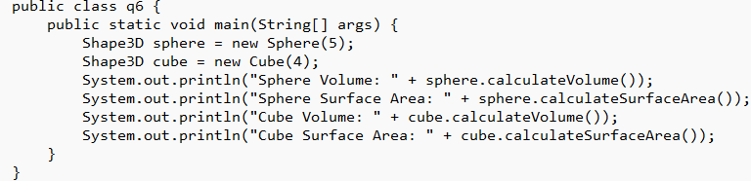
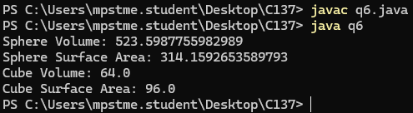

7. Write a Java program to create an abstract class Instrument with abstract methods play()
and tune(). Create subclasses for Glockenspiel and Violin that extend the Instrument class
and implement the respective methods to play and tune each instrument.
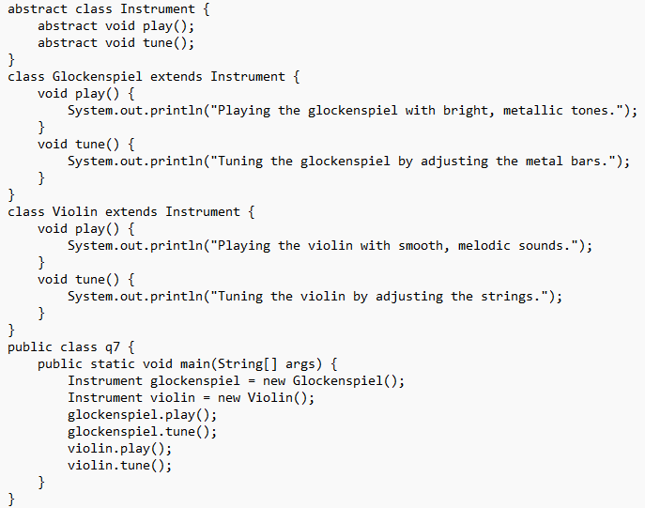
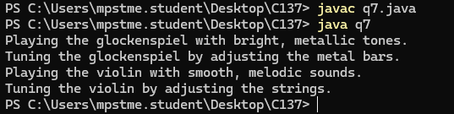
8. Create an online shopping system where different product categories are managed using
multi-level inheritance. The base class, Product, should contain attributes like
productName and price. The Electronics class should extend Product, adding attributes
such as warrantyPeriod and a method showWarrantyDetails(). Further, the Laptop class
should inherit from Electronics and introduce a batteryBackup attribute and a method
displayLaptopSpecifications(). The system should show how a Laptop object can utilize
functionalities from both Electronics and Product.
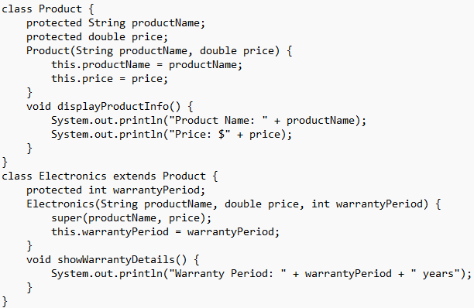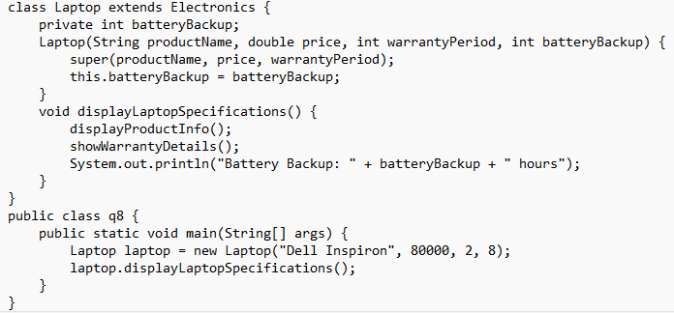
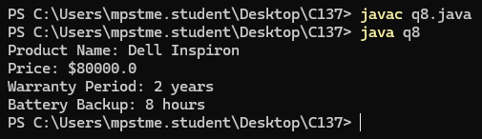
A) Create a base class Person with data members name and age and a method display().
Create a derived class Student that extends Person and adds a data member rollNo.
Display all the details using an object of the Student class.
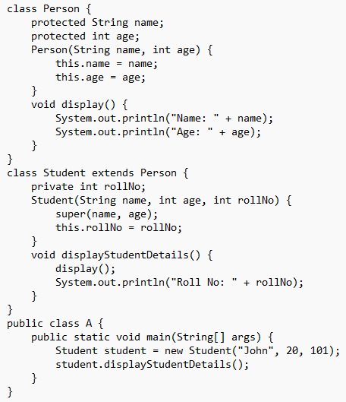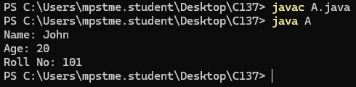
B) Create a class Vehicle with a method start().
Derive a class Car from Vehicle with a method fuelType().
Further derive a class ElectricCar from Car with a method batteryCapacity().
Demonstrate multilevel inheritance.
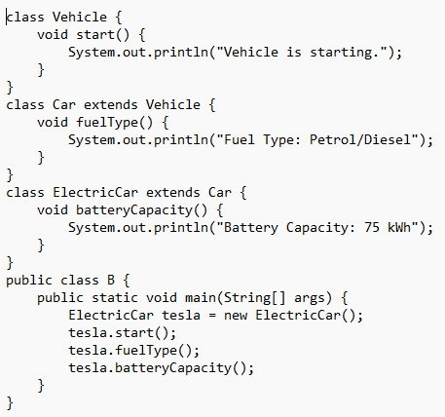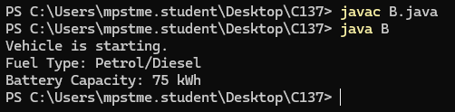
C) Create a base class Bank with a method getRateOfInterest().
Create subclasses SBI and ICICI that override the method to return different interest rates.
Demonstrate method overriding.
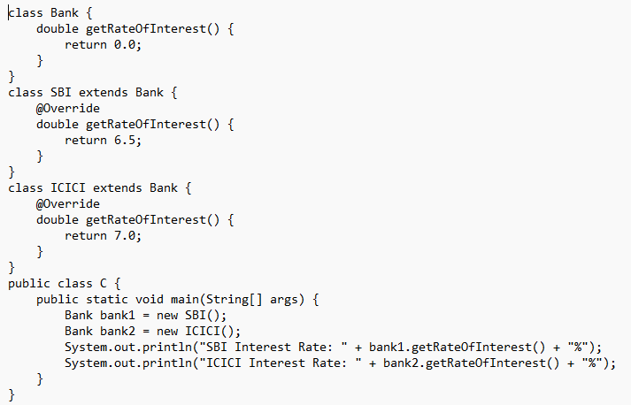
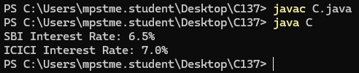
D) Create a base class Vehicle with a method maxSpeed().
Create subclasses Car and Bike that override the method to display different maximum
speeds.
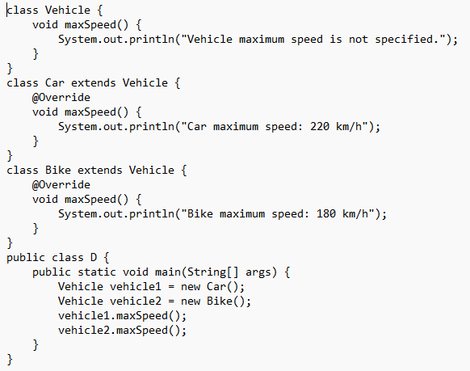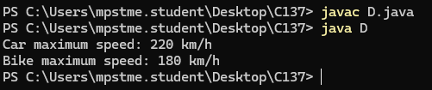
E) Create an abstract class Shape with an abstract method calculateArea().
Create two subclasses Rectangle and Circle that implement the abstract method to calculate
and display the area.
Demonstrate the use of abstract class.
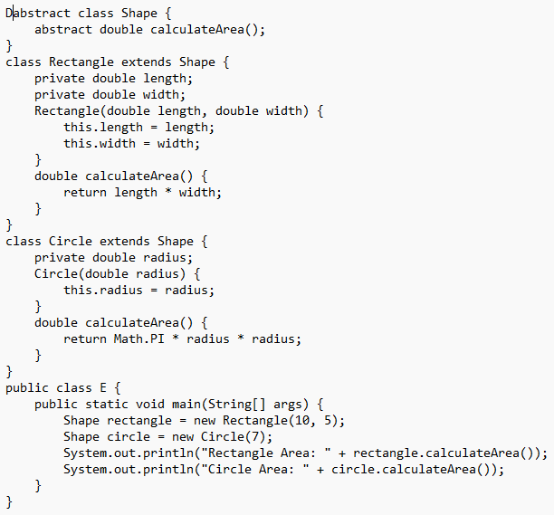
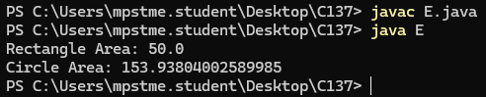

F) Create an abstract class Employee with an abstract method calculateSalary().
Create two subclasses FullTimeEmployee and PartTimeEmployee that implement the
method to calculate salary.
Demonstrate abstraction.
